**QUESTION 1:**

.MODEL SMALL

.STACK 100H

.DATA

.CODE

MAIN PROC

MOV AX,@DATA

MOV DS,AX

Mov Al,01h

int 21h

Mov dl,Al

int 21h

Mov Ah,4ch

int 21h

main endp

end main

**QUESTION 2:**

.MODEL SMALL

.STACK 100H

.DATA

.CODE

MAIN PROC

MOV AX,@DATA

MOV DS,AX

MOv dl,30h

Mov Ah,02h

int 21h

MOv dl,31h

Mov Ah,02h

int 21h

MOv dl,32h

Mov Ah,02h

int 21h

MOv dl,33h

Mov Ah,02h

int 21h

MOv dl,34h

Mov Ah,02h

int 21h

MOv dl,35h

Mov Ah,02h

int 21h

MOv dl,36h

Mov Ah,02h

int 21h

MOv dl,37h

Mov Ah,02h

int 21h

MOv dl,38h

Mov Ah,02h

int 21h

MOv dl,39h

Mov Ah,02h

int 21h

Mov Ah,4ch

int 21h

main endp

end main

**Question 3:**

.MODEL SMALL

.STACK 100H

.DATA

.CODE

MAIN PROC

MOV AX,@DATA

MOV DS,AX

MOv dl,48

Mov Ah,02h

int 21h

MOv dl,49

Mov Ah,02h

int 21h

MOv dl,50

Mov Ah,02h

int 21h

MOv dl,51

Mov Ah,02h

int 21h

MOv dl,52

Mov Ah,02h

int 21h

MOv dl,53

Mov Ah,02h

int 21h

MOv dl,54

Mov Ah,02h

int 21h

MOv dl,55

Mov Ah,02h

int 21h

MOv dl,56

Mov Ah,02h

int 21h

MOv dl,57

Mov Ah,02h

int 21h

Mov Ah,4ch

int 21h

main endp

end main

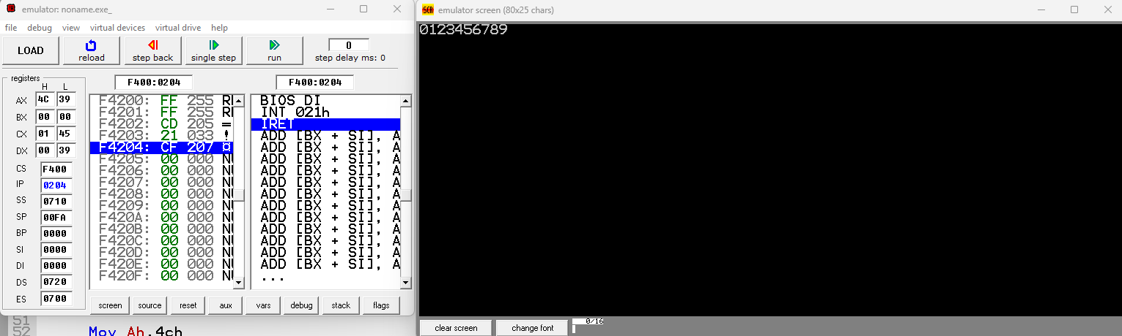

**Question 4:**

.MODEL SMALL

.STACK 100H

.DATA

.CODE

MAIN PROC

MOV AX,@DATA

MOV DS,AX

MOv dl,48

Mov Ah,02h

int 21h

Mov dl,0ah

int 21h

MOv dl,0dh

int 21h

MOv dl,49

Mov Ah,02h

int 21h

Mov dl,0ah

int 21h

MOv dl,0dh

int 21h

MOv dl,50

Mov Ah,02h

int 21h

Mov dl,0ah

int 21h

MOv dl,0dh

int 21h

MOv dl,51

Mov Ah,02h

int 21h

Mov dl,0ah

int 21h

MOv dl,0dh

int 21h

MOv dl,52

Mov Ah,02h

int 21h

Mov dl,0ah

int 21h

MOv dl,0dh

int 21h

MOv dl,53

Mov Ah,02h

int 21h

Mov dl,0ah

int 21h

MOv dl,0dh

int 21h

MOv dl,54

Mov Ah,02h

int 21h

Mov dl,0ah

int 21h

MOv dl,0dh

int 21h

MOv dl,55

Mov Ah,02h

int 21h

Mov dl,0ah

int 21h

MOv dl,0dh

int 21h

MOv dl,56

Mov Ah,02h

int 21h

Mov dl,0ah

int 21h

MOv dl,0dh

int 21h

MOv dl,57

Mov Ah,02h

int 21h

Mov Ah,4ch

int 21h

main endp

end main

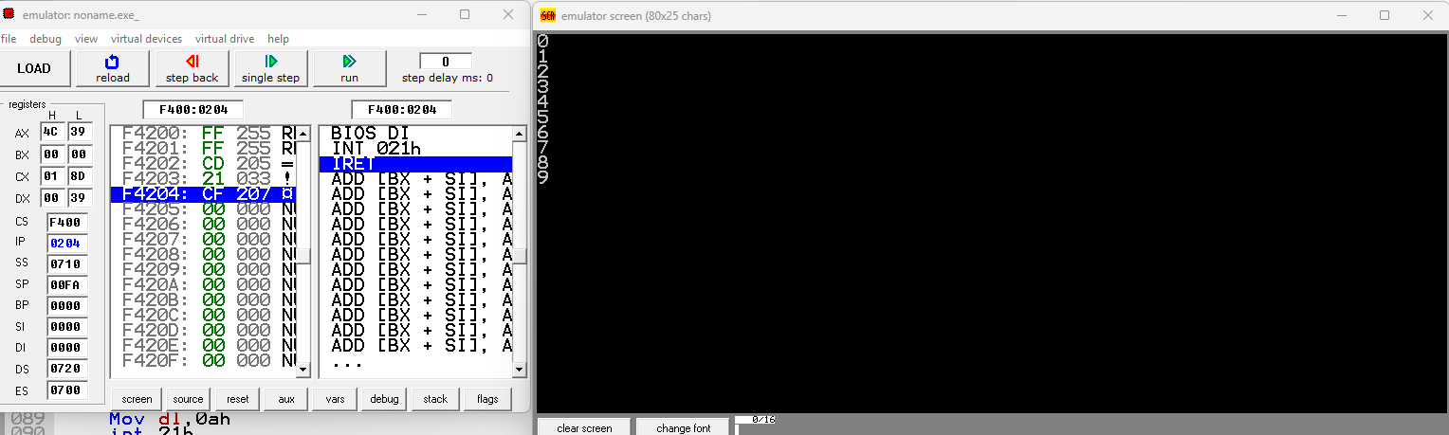

**question 6:**

.MODEL SMALL

.STACK 100H

.DATA

.CODE

MAIN PROC

MOV AX,@DATA

MOV DS,AX

MOv dl,41h

Mov Ah,02h

int 21h

MOv dl,42h

Mov Ah,02h

int 21h

MOv dl,44h

Mov Ah,02h

int 21h

MOv dl,55h

Mov Ah,02h

int 21h

MOv dl,4Ch

Mov Ah,02h

int 21h

MOv dl,4Ch

Mov Ah,02h

int 21h

MOv dl,41h

Mov Ah,02h

int 21h

MOv dl,48h

Mov Ah,02h

int 21h

Mov Ah,4ch

int 21h

main endp

end main

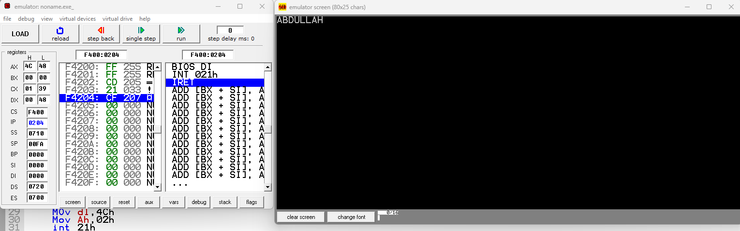

**question 7:**

.MODEL SMALL

.STACK 100H

.DATA

.CODE

MAIN PROC

MOV AX,@DATA

MOV DS,AX

MOv dl,41h

Mov Ah,02h

int 21h

Mov dl,0ah

int 21h

Mov dl,0dh

int 21h

MOv dl,42h

Mov Ah,02h

int 21h

Mov dl,0ah

int 21h

Mov dl,0dh

int 21h

MOv dl,44h

Mov Ah,02h

int 21h

Mov dl,0ah

int 21h

Mov dl,0dh

int 21h

MOv dl,55h

Mov Ah,02h

int 21h

Mov dl,0ah

int 21h

Mov dl,0dh

int 21h

MOv dl,4Ch

Mov Ah,02h

int 21h

Mov dl,0ah

int 21h

Mov dl,0dh

int 21h

MOv dl,4Ch

Mov Ah,02h

int 21h

Mov dl,0ah

int 21h

Mov dl,0dh

int 21h

Mov dl,41h

Mov Ah,02h

int 21h

Mov dl,0ah

int 21h

Mov dl,0dh

int 21h

MOv dl,48h

Mov Ah,02h

int 21h

Mov Ah,4ch

int 21h

main endp

end main

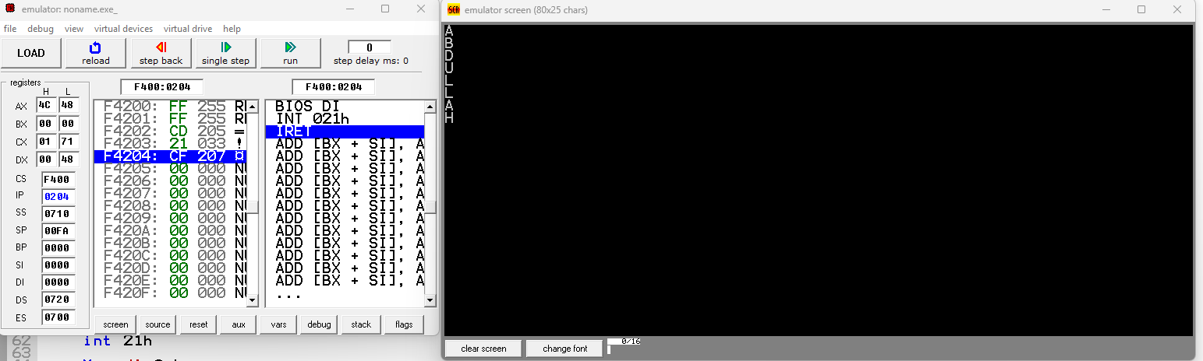

**Question 5:**

.MODEL SMALL

.STACK 100H

.DATA

.CODE

MAIN PROC

MOV AX, @DATA

MOV DS, AX

MOV DL, 65

MOV AH, 02h

INT 21h

MOV AH, 4Ch

INT 21h

MAIN ENDP

END MAIN

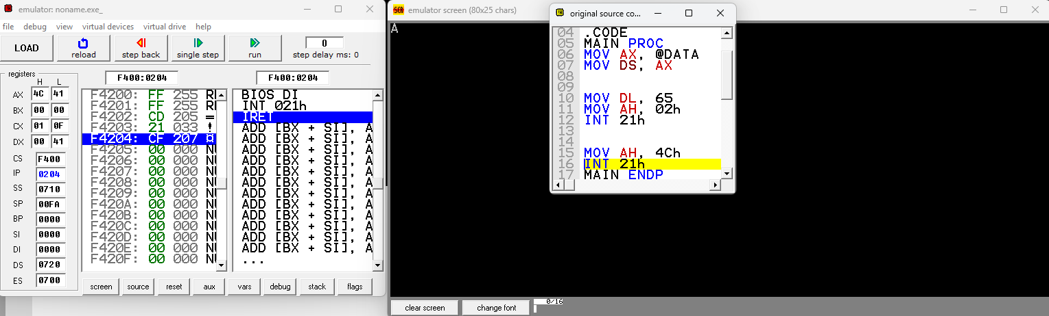

**Part 4:**.MODEL SMALL

.STACK 100H

.DATA

.CODE

MAIN PROC

MOV AX,@DATA

MOV DS,AX

Mov dl,42

Mov Ah,02h

int 21h

MOv dl,42

Mov Ah,02h

int 21h

MOv dl,42

Mov Ah,02h

int 21h

Mov dl,0ah

int 21h

Mov dl,0dh

int 21h

Mov dl,42

Mov Ah,02h

int 21h

MOv dl,42

Mov Ah,02h

int 21h

MOv dl,42

Mov Ah,02h

int 21h

Mov dl,0ah

int 21h

Mov dl,0dh

int 21h

Mov dl,42

Mov Ah,02h

int 21h

MOv dl,42

Mov Ah,02h

int 21h

MOv dl,42

Mov Ah,02h

int 21h

Mov Ah,4ch

int 21h

main endp

end main

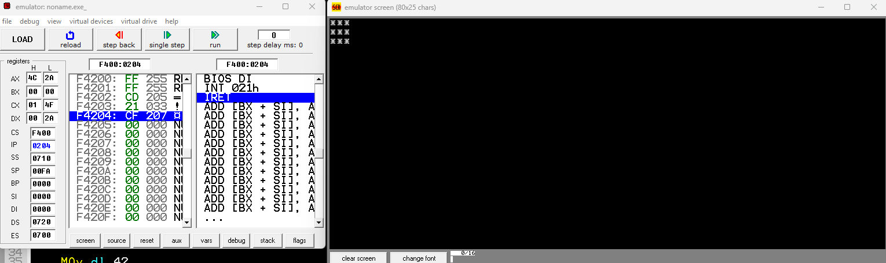

**Part 2:**

.MODEL SMALL

.STACK 100H

.DATA

.CODE

MAIN PROC

MOV AX,@DATA

MOV DS,AX

Mov Ax,54d

Mov Bx,21d

Mov Dx,Ax

Mov Ax,Bx

Mov Bx,Dx

Mov Ah,4ch

int 21h

main endp

end main

**Part 1:**

.MODEL SMALL

.STACK 100H

.DATA

.CODE

MAIN PROC

MOV AX,@DATA

MOV DS,AX

MOv dl,41h

Mov Ah,02h

int 21h

Mov dl,0ah

int 21h

MOv dl,42h

Mov Ah,02h

int 21h

Mov dl,0ah

int 21h

Mov dl,0dh

int 21h

MOv dl,44h

Mov Ah,02h

int 21h

Mov dl,0ah

int 21h

MOv dl,55h

Mov Ah,02h

int 21h

Mov dl,0ah

int 21h

Mov dl,0dh

int 21h

MOv dl,4Ch

Mov Ah,02h

int 21h

Mov dl,0ah

int 21h

MOv dl,4Ch

Mov Ah,02h

int 21h

Mov dl,0ah

int 21h

Mov dl,0dh

int 21h

Mov dl,41h

Mov Ah,02h

int 21h

Mov dl,0ah

int 21h

MOv dl,48h

Mov Ah,02h

int 21h

Mov Ah,4ch

int 21h

main endp

end main

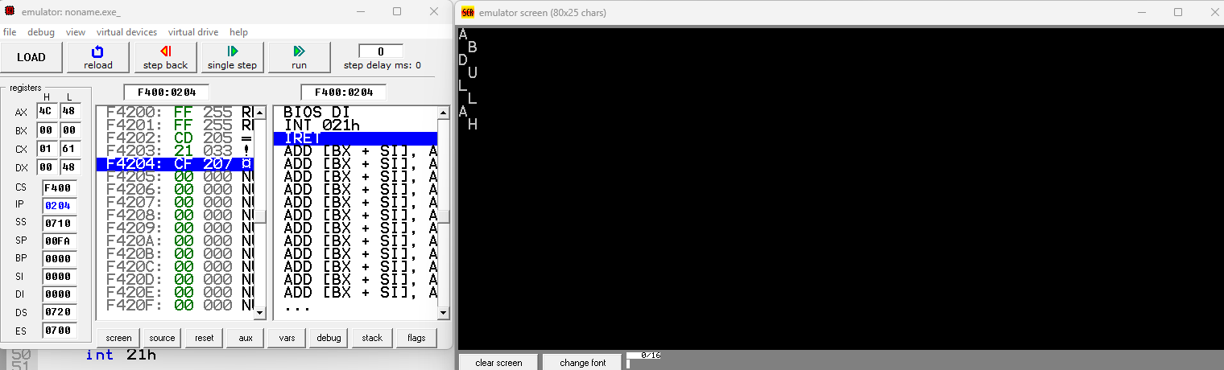

**Part 2:**

.MODEL SMALL

.STACK 100H

.DATA

.CODE

MAIN PROC

MOV AX,@DATA

MOV DS,AX

MOv Ah,01h

int 21h

Mov Dl,Al

Mov Ah,02h

int 21h

Mov Ah,4ch

int 21h

main endp

end main

